**Read or Queries the Documents into Collections**

**Note:** db.collection.find(query, projection)

1. **Find all the result of the given collection.**  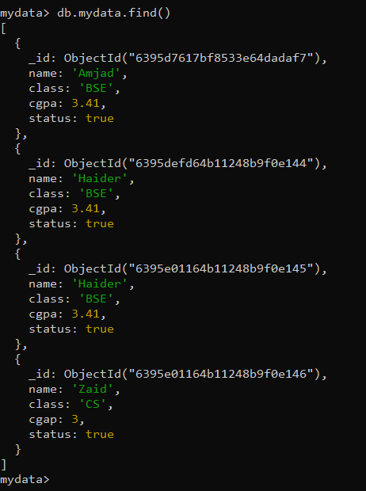
2. **Show the result in pretty format?**  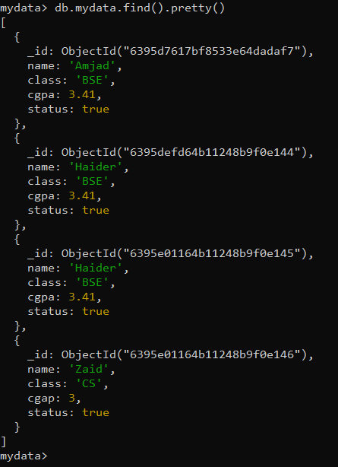
3. **Get only Haider data as a output.** 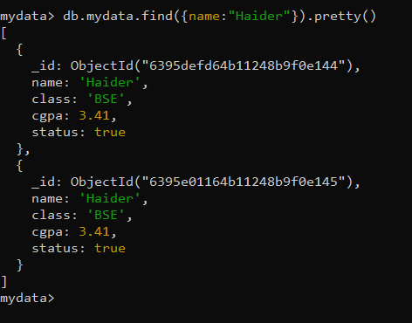
4. **Get only Haider data as a output with only name field.** 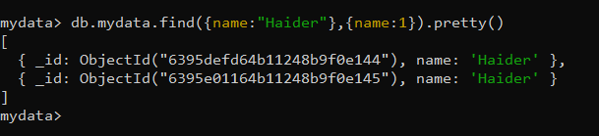
5. **Get the Haider data with name and without _ID field in it.** 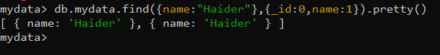
6. **set the filter to "status:true" and get only the first field with "status:true" value.**  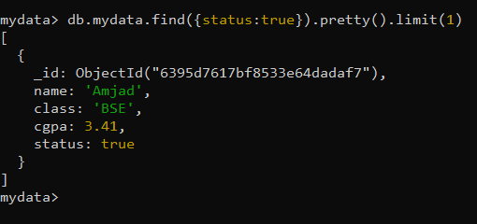
7. **Do the same as 6th question but with different method.** 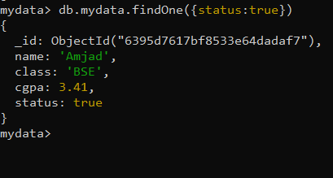
8. **Do the same as 6th question but this time, get the 2nd field with active:true by skipping the 1st field.** 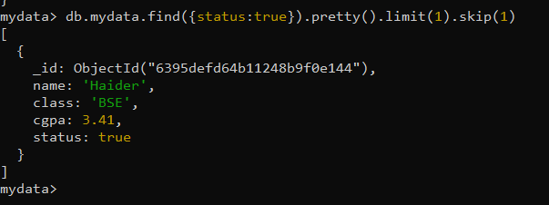
9. **Show only name and class field of collection.** 